* CSS stands for Cascading Style Sheets

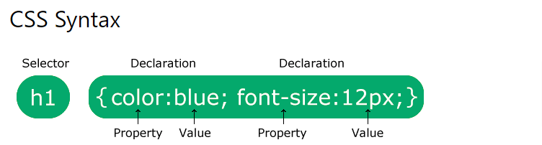

CSS selectors are used to "find" (or select) the HTML elements you want to style.

1. Calss name ( ex: .salah)
2. Id name ( ex : #haitham)
3. Tag name ( ex : h1 , p , span , …. etc)

The CSS Universal Selector * by this you select all elements in the page

You can group selectors to gether with comma

Example:

H1,p,.salah,#mohaed{color:red}

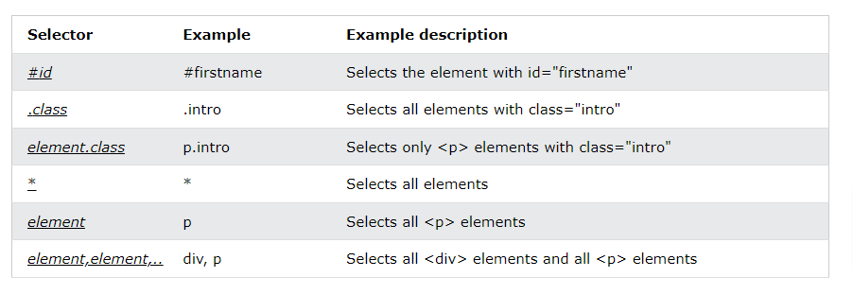

Three Ways to Insert CSS

There are three ways of inserting a style sheet:

* External CSS
* Internal CSS
* Inline CSS

rule in **red** color refere to that rule is common used

rule in **blue** is the most common used

**background-color: red;**

 **background-image: url("img_tree.png");  
  background-repeat: no-repeat;  
  background-position: right top;**

[**background-size**](https://www.w3schools.com/cssref/css3_pr_background-size.asp) **: cover**

**border: 5px solid red;**

**margin: 100px 0;**

**padding-top: 50px 10px;**

**text-align: center**; / left / right

**text-decoration-line: underline**;

**text-transform: uppercase** lowercase / capitalize;

letter-spacing: 5px; space between letters

**line-height: 1.8; vertically height content based on element height**

 word-spacing: 10px; space between words

**white-space: nowrap / normal ; break text to new line or not based on value**

**ex: white-space: nowrap; make paragraph to be in one line**

**font-family: "Times New Roman", Times, serif;**

**a:hover div:hover span:hover ( refere to mouse over element)**

**list-style-type: none;**

display: none;

 visibility: hidden;

The position property specifies the type of positioning method used for an element.

There are five different position values:

* static
* **relative**
* fixed
* **absolute**
* sticky

## The z-index Property

The z-index property specifies the stack order of an element.

## CSS Overflow

## overflow: visible

## overflow: hidden

## overflow: scroll

## overflow: auto

## The float Property

* left - The element floats to the left of its container
* right - The element floats to the right of its container

.clearfix {  
  overflow: hidden;  
}

.clearfix::after {  
  content: "";  
  clear: both;  
  display: table;  
}

There are four different combinators in CSS:

* descendant selector (space)
* **child selector (>)**
* adjacent sibling selector (+)
* **general sibling selector (~)**

div p {  
  background-color: yellow;  
}

## What are Pseudo-classes?

Div:hover

**p:first-child {  
  color: blue;  
}**

**p:last-child {  
  color: blue;  
}**

p::first-line

**p::first-letter**

**::before**

**::after**

**Display :flex**

**Aligin-items**

**Justify-content**